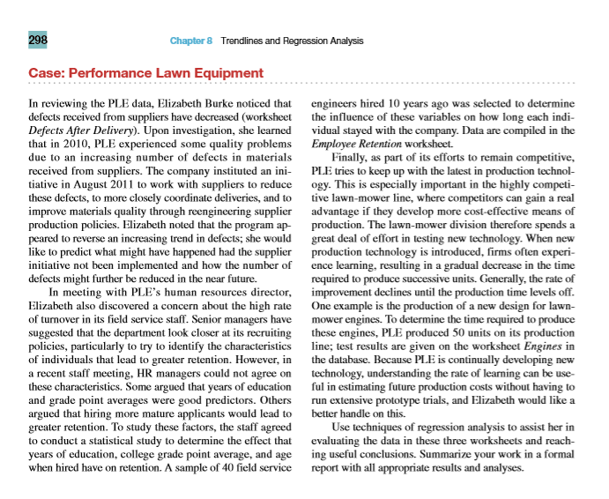

Key points:

* Defects after Delivery worksheet
* In 2010 there was supplier problems – Aug 2011 new policies set up to reduce defects.
* Predict what might happen if the supplier initiative had not been implemented and how the number of defects might be further reduced in the future
* Employee Retention worksheet.
* Find the predictors for employee retention
* Engines worksheet
* Using rate of learning to estimate future production costs
* (new tech is introduced -> learning leads to fall in prod time -> rate of learning declines -> prod time levels off)